DATABASE LAB FINAL EXAM

Name: Ahmed Kasteer

Roll Number: 20F-0336

Section: 4D

PART 1

**Question1:**

Query:

select ENAME, JOB, HIREDATE

from EMP

Where ENAME ='Matos' AND ENAME = 'TAYLOR'

ORDER BY HIREDATE

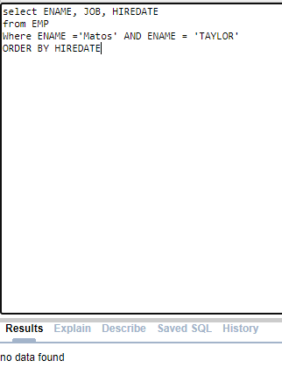

No last name attribute in table.

**Question 2:**

**Query:**

**No data found for 1994**

SELECT ENAME, HIREDATE

FROM EMP

WHERE HIREDATE LIKE '__/__/1994'

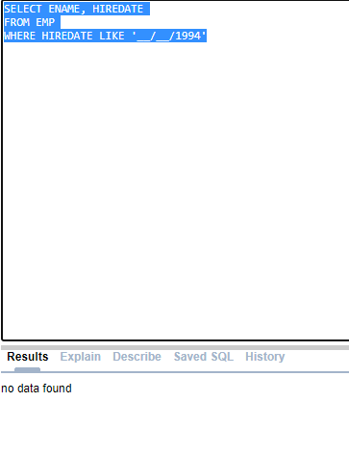

**QUESTION3:**

**QUERY**

SELECT DEPTNO as DEPTNO, JOB as JOB, SAL as SALARY, DEPTNO

FROM EMP

WHERE DEPTNO = '20' and DEPTNO ='50' and DEPTNO = '80' and DEPTNO = '90'

No dept 90 or 80 or 50

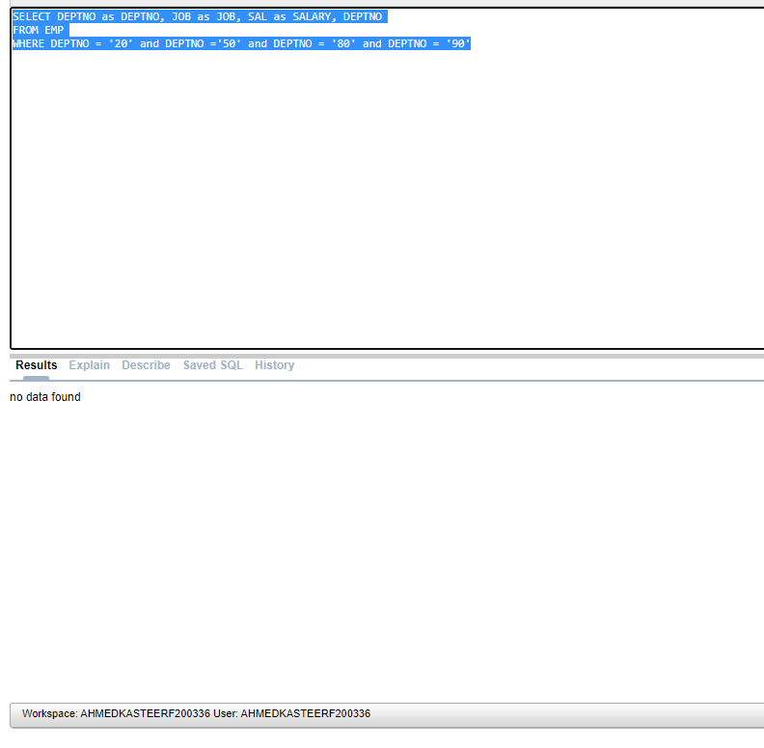

**Question4:**

SELECT MGR, MIN(SAL) as MINSALARY

FROM EMP

WHERE MGR IS NOT NULL

GROUP BY MGR

**ORDER BY MIN(SAL) DESC**

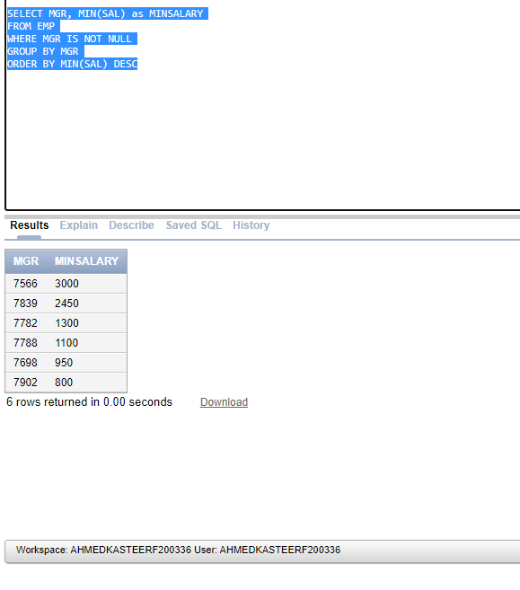

**PART 2**

**Respected Instructor, I was unable to attach tables on SQL server because it was taking a long time to connect during which my Lab PC Viper crashed 3-4 times. I asked the Lab Attendant to help me but he said it was the error on my end. I rest my case in God’s hands.**

**Question1:**

SELECT ORG_NAME

FROM EVENTORGANZIER

WHERE ORG_NAME = ( SELECT S_name

FROM Society

WHERE S_name like 'F%');

**Question 2:**

SELECT ORG_NAME

FROM DEPT

WHERE Department = (SELECT deptname

FROM SOCIETY

WHERE S_name = ‘Symphonic’);

**Question 3:**

SELECT *

FROM Events

WHERE E_name = (SELECT S_name

FROM SOCIETY

WHERE E_name = ‘NULL’);

**Question 4:**

SELECT *

FROM EVENTORGANIZER

WHERE ORG_id = (SELECT ORGID

FROM Society

WHERE EVENTS.id = ‘NULL’);

**PART 4**

**Question: Create a package based on your roll number:**

**i)**

DECLARE

CREATE PACKAGE F20-0336 as

Function register_class(student_id,class_id) (RETURN) [VARCHAR(25), VARCHAR(20)]

*/ function body

SELECT Student

FROM EDU

INSERT VALUES INTO STUDENT(‘334455’, ‘Abubakar’, ‘Maths’, ‘LGS’)

*/

return register_class

end function

END/

**PART 5**

**Question1:**

DECLARE

CURSOR c_v IS

BEGIN

FOR v_c IN c_v

SELECT ENAME, EMPNO

FROM EMP

WHERE DEPTNO = '10'

dbms_output.put_line("Name is" || ENAME)

dbms_output.put_line("Emp No is" || EMPNO)

END/

**Question2:**

DECLARE

CURSOR salary IS

v_c NUMBER :=

BEGIN

FOR v_c IN salary

SELECT ENAME, SAL

FROM EMP

WHERE SAL > 3500 and JOB = “SALESMAN”

dbms_output.put_line("Name is" || ENAME)

dbms_output.put_line("SALARY is" || SAL)

dbms_output.put_line(“JOB CURRENTLY IS”|| JOB”)

END/

**Question3:**

CREATE Trigger trigger_t3

BEFORE

INSERTION

for each row

SELECT ENAME from EMP

INSERT VALUES INTO EMP (‘7999’, ‘AHMED’, ‘PRESIDENT’, ‘7777’, ‘21/12/1999’, ‘6000’, NULL, ‘50’)

DELETE FROM EMP VALUES (‘7969’, ‘WHITE’, ‘SALESMAN’, ‘5566’, ‘10/05/1988’, ‘4000’, NULL, ‘20’)

UPDATE INTO EMP VALUES (‘7969’, ‘WHITE’, ‘SALESMAN’, ‘5566’, ‘10/05/1988’, ‘4000’, NULL, ‘20’) AS

(‘7900’, ‘BLACK’, ‘PRESIDENT’, ‘5446’, ‘02/02/1988’, ‘1110000’, NULL, ‘20’)

end/